**Lab Cycle 8 -** Write a program in PHP to change background color based on day of the week using if **else if statements and using arrays**

<!DOCTYPE html>

<html>

<head>

<title>Change Background Color by Day of the Week</title>

<style> body {

text-align: center; font-size: 24px; padding: 50px;

}

</style>

</head>

<body>

<?php

// Array to store background colors for each day of the week

$backgroundColors = array( "Sunday" => "#ff6666", "Monday" => "#ffcc99", "Tuesday" => "#99ff99", "Wednesday" => "#66b3ff", "Thursday" => "#ff99cc", "Friday" => "#ffff99", "Saturday" => "#cc99ff"

);

// Get the current day of the week

$currentDay = date("l"); // Set the background color based on the current day

if (array_key_exists($currentDay, $backgroundColors)) {

$backgroundColor = $backgroundColors[$currentDay];

} else {

$backgroundColor = "#f2f2f2"; // Default background color

}

?>

<h1>Background Color of the Day</h1>

<div style="background-color: <?php echo $backgroundColor; ?>"> Today is <?php echo $currentDay; ?>

</div>

</body>

</html>

## Output



**Lab Cycle 9** - .Write a simple program in PHP for i) generating Prime number ii) generate Fibonacci series.

<?php

function isPrime($number) { if ($number <= 1) {

return false;

}

if ($number <= 3) { return true;

}

if ($number % 2 == 0 || $number % 3 == 0) { return false;

}

for ($i = 5; $i * $i <= $number; $i += 6) {

if ($number % $i == 0 || $number % ($i + 2) == 0) { return false;

}

}

return true;

}

echo "Prime Numbers: "; for ($i = 2; $i <= 50; $i++) { if (isPrime($i)) {

echo $i . " ";

}

}

echo "\nFibonacci Series: ";

$n = 10; // Number of Fibonacci numbers to generate

$a = 0;

$b = 1;

for ($i = 0; $i < $n; $i++) { echo $a . " ";

$c = $a + $b;

$a = $b;

$b = $c;

}

?>

Output

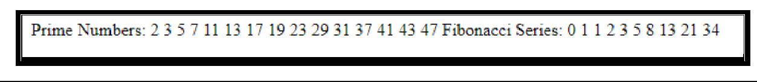

**Lab Cycle 10:** Write a PHP program to remove duplicates from a sorted list.

<?php

function removeDuplicates($sortedList) {

$length = count($sortedList); if ($length == 0) {

return $sortedList;

}

$result = array($sortedList[0]); for ($i = 1; $i < $length; $i++) {

if ($sortedList[$i] != $sortedList[$i - 1]) {

$result[] = $sortedList[$i];

}

}

return $result;

}

// Sample sorted list with duplicates

$sortedList = array(1, 2, 2, 3, 4, 4, 4, 5, 6, 6, 7);

// Call the removeDuplicates function

$uniqueList = removeDuplicates($sortedList);

echo "Original Sorted List: " . implode(", ", $sortedList) . "\n";

echo "List with Duplicates Removed: " . implode(", ", $uniqueList) . "\n";

?>

## Output

Original Sorted List: 1, 2, 2, 3, 4, 4, 4, 5, 6, 6, 7

List with Duplicates Removed: 1, 2, 3, 4, 5, 6

**Lab Cycle 11:** Write a PHP Script to print the following pattern on the Screen

<?php

$rows = 5; // Number of rows in the pattern

<?php

//$rows = 5; // Number of rows in the pattern for ($i = 1; $i <= 5; $i++) {

for ($j = 5; $j >= $i; $j--) { echo "*";

}

echo "\n";

}

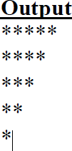?>

**Lab Cycle- 12 :** Write a PHP program to Create a simple webpage of a college

<!DOCTYPE html>

<html>

<head>

<title>College Name - Home</title>

<style> body {

font-family: Arial, sans-serif;

}

header {

background-color: #007ACC; color: #fff;

text-align: center; padding: 20px;

}

h1 { margin: 0;

}

nav {

background-color: #333; color: #fff;

padding: 10px;

}

nav a { color: #fff;

text-decoration: none; margin-right: 20px;

}

.content { padding: 20px;

}

footer {

background-color: #333; color: #fff;

text-align: center; padding: 10px;

}

</style>

</head>

<body>

<header>

<h1>SINDHI COLLEGE</h1>

<p><b>Knowledge is Power<b></p>

</header>

<nav>

<a href="#">Home</a>

<a href="#">Programs</a>

<a href="#">Admissions</a>

<a href="#">About Us</a>

<a href="#">Contact Us</a>

</nav>

<div class="content">

<h2>Welcome to SINDHI COLLEGE </h2>

<p>

Welcome to Sindhi College , where we are committed to providing a quality education and empowering the future.

</p>

</div>

<footer>

&copy; <?php echo date("Y"); ?> Sindhi College

</footer>

</body>

</html>

# Output

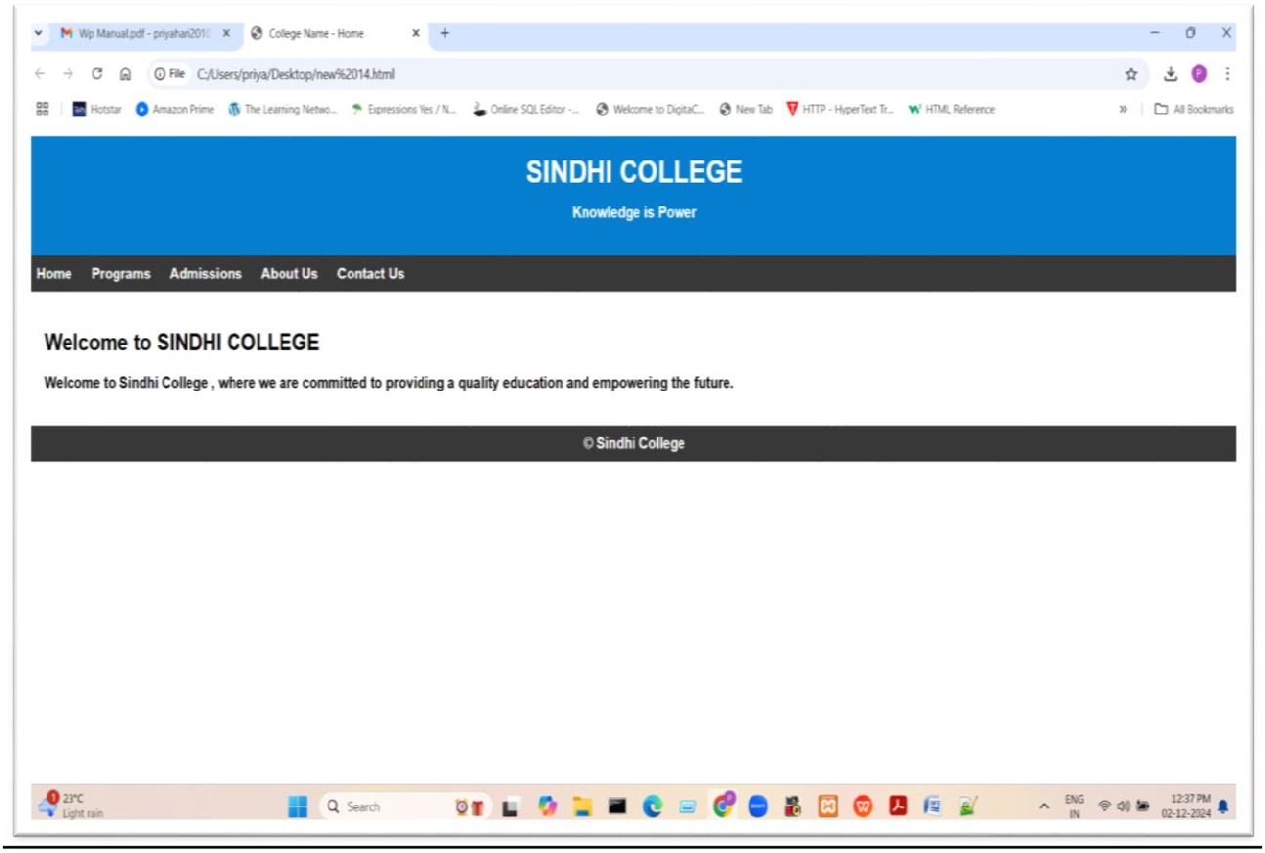

**Lab Cycle : 13 -** Write a program in PHP for exception handling for i) divide by zero ii) checking date format.

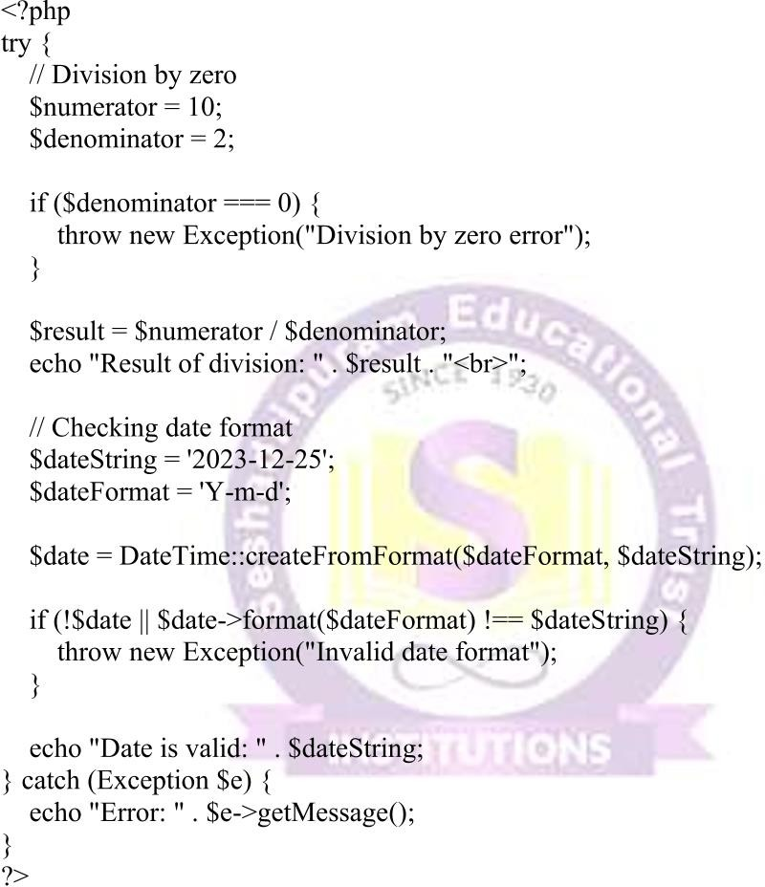

# Output

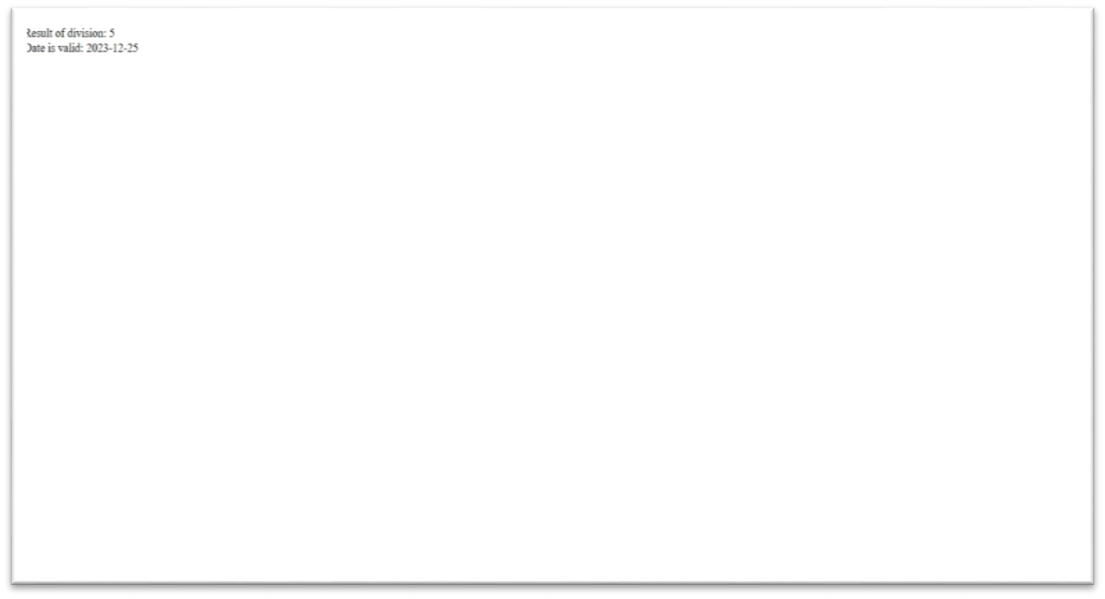

**Lab Cycle 14 : -** Write a PHP program to set and retrieve a cookie

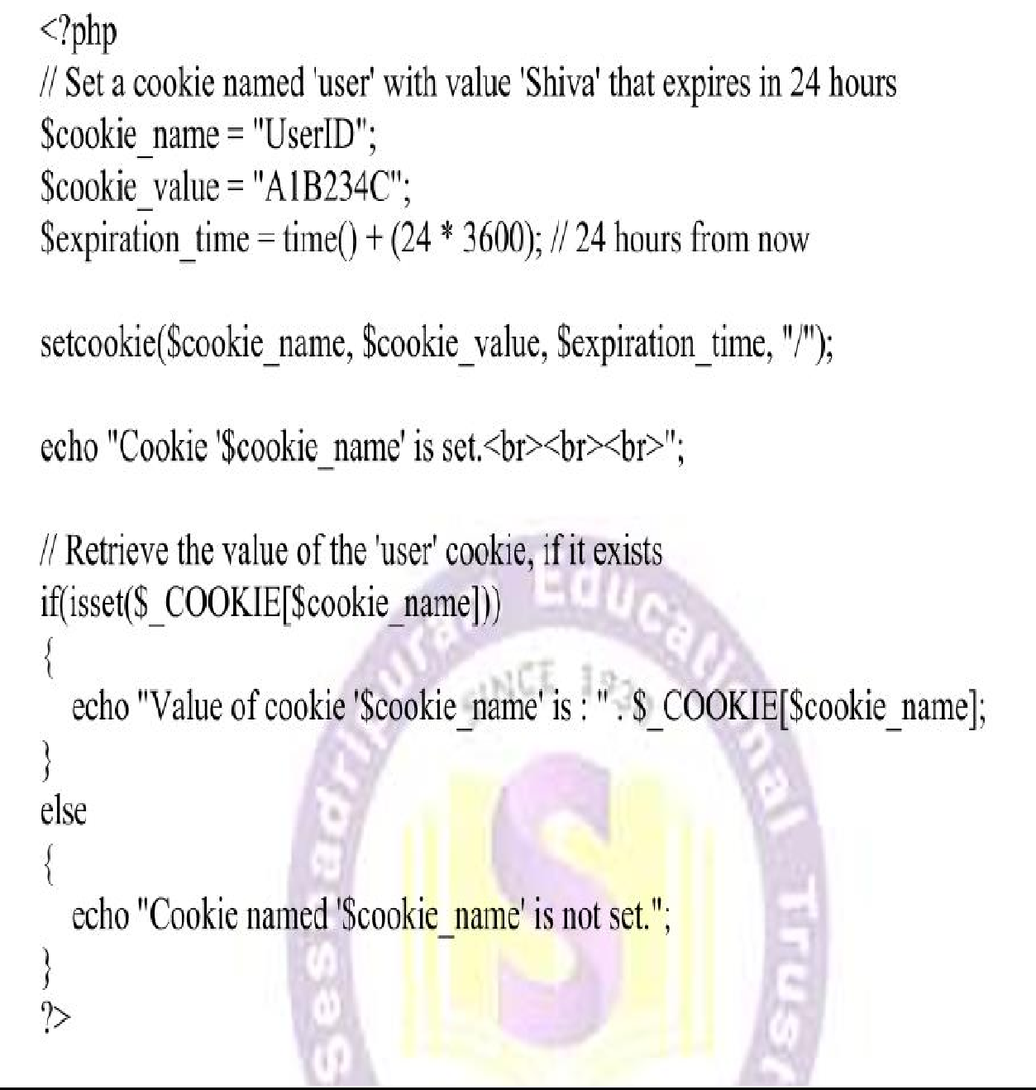

# Output

